Project Documentation

1. Project Overview
This project implements a complete end-to-end retail data engineering and analytics pipeline designed to transform raw retail transaction data into a clean, structured and analytics-ready dataset suitable for business intelligence reporting and decision making.
The solution was developed using a local development environment consisting of VS Code, Jupyter Notebook, Python, Pandas and Power BI. The project follows a data engineering workflow involving data ingestion, validation, cleaning, transformation, integration, KPI generation and reporting.
The project uses multiple source datasets provided in Excel format, including:
- Retail Data 1
- Retail Data 2
- Product Dimension Table
The retail datasets contain transactional business information such as transaction identifiers, customer details, product identifiers, prices, quantities, transaction dates, payment methods, discounts, purchase locations and payment status information.
The accompanying Product Dimension Table contains standardized product metadata including product identifiers, product names and category information which serve as the reference dataset for product standardization and dimensional enrichment.
The primary objective of this project is to build a reliable data pipeline capable of performing:
- Data ingestion from source Excel files
- Data quality validation
- Schema consistency checks
- Missing value handling
- Invalid business record detection and removal
- Data standardization and transformation
- Product dimension integration
- Personally Identifiable Information (PII) protection
- KPI calculation
- Curated dataset generation
- Business intelligence reporting using Power BI
During implementation, the raw retail transaction data required multiple preprocessing operations before becoming suitable for analytical reporting. Several data quality issues were identified, including missing prices, inconsistent category naming conventions, inconsistent product labels and invalid quantity records.
These issues were addressed through a structured cleaning and transformation framework.
Missing prices were handled using product-level average price imputation, invalid business records were removed using predefined business validation rules and categorical inconsistencies were standardized to maintain analytical consistency across the dataset.
Since the dataset contains customer contact information such as email addresses and phone numbers, privacy protection mechanisms were incorporated through PII masking techniques to reduce exposure of sensitive customer information.
After completing ingestion, cleaning and transformation operations, the retail transaction datasets were integrated with the standardized product dimension table using product_id as the common join key.
The transformed analytical dataset was then used to generate multiple business KPIs and performance metrics including:
- Total Revenue
- Revenue by Category
- Revenue by City
- Revenue by Payment Method
- Average Revenue
- Total Orders
A business-ready curated dataset was finally exported as a CSV file and used as the data source for Power BI dashboard development.
The final solution demonstrates a practical retail data engineering workflow that emphasizes data quality, data consistency, privacy protection, dimensional modeling, KPI generation and business intelligence reporting.

2. Dataset Documentation
Retail Transaction Dataset Structure
The retail transaction dataset represents transactional sales data collected from multiple retail source files. The dataset contains detailed information related to customers, purchased products, transaction details, pricing information, payment information and purchase locations.
The retail transaction dataset serves as the primary fact dataset used for data engineering operations, KPI generation and business intelligence reporting.
The structure of the retail transaction dataset is described below.
Column Name | Data Description
transaction_id | Unique identifier assigned to each transaction record
customer_id | Unique identifier assigned to each customer
customer_name | Full name of the customer involved in the transaction
product_id | Unique identifier assigned to the purchased product
product_name | Name of the purchased product
category | Product category classification
price | Selling price of the product
quantity | Number of units purchased
discount | Discount percentage applied to the transaction
purchase_location | Purchase channel indicating online or offline purchase
city | Geographic location where the transaction occurred
transaction_date | Date on which the transaction was performed
payment_method | Payment method used by the customer
email | Customer email address
phone | Customer phone number
payment_status | Transaction payment completion status
The retail transaction dataset contains business-critical transactional information required for downstream analytics, reporting and KPI calculation.

Product Dimension Dataset Structure (product_dim)
The project also uses a standardized Product Dimension Table (product_dim).
The product dimension dataset acts as the reference dataset containing standardized product information used for dimensional enrichment and analytical consistency.
The structure of the Product Dimension dataset is described below.
Column Name | Data Description
product_id | Unique identifier assigned to the product
product_name | Standardized product name
category | Standardized product category
price | Standardized reference price associated with the product
The Product Dimension Table provides standardized product metadata used to enrich the retail transaction dataset during the merge stage of the pipeline.
The dimension table ensures consistency in:
- Product Naming
- Category Classification
- Reference Product Information
- Analytical Grouping

Dataset Characteristics
The retail transaction dataset contains several important business attributes used for analytics and reporting.
The dataset includes:
Transaction Attributes
These fields capture transactional business activity.
Examples include:
- transaction_id
- transaction_date
- payment_method
- payment_status
- purchase_location
These columns are important for transaction-level analysis, sales monitoring and operational reporting.
Customer Attributes
These fields contain customer-related information.
Examples include:
- customer_id
- customer_name
- email
- phone
Since customer information includes Personally Identifiable Information (PII), privacy protection measures were applied during preprocessing.
Product Attributes
These fields capture product-related information.
Examples include:
- product_id
- product_name
- category
- price
- quantity
- discount
These attributes support revenue calculation, category analysis, product-level reporting and KPI generation.
Geographic Attributes
The dataset also contains location-based analytical information.
Examples include:
- city
- purchase_location
These fields enable geographic revenue analysis and city-level reporting.

Dataset Usage within the Pipeline
The datasets are used throughout multiple stages of the pipeline.
The retail transaction dataset is used for:
- Data ingestion
- Validation checks
- Data cleaning
- Transformation logic
- KPI generation
- Power BI reporting
The Product Dimension Table is used for:
- Product standardization
- Category normalization
- Dimensional enrichment
- Merge operations
- Analytical consistency
Both datasets are integrated using product_id as the common business key.
The merged dataset forms the basis of the final analytical dataset exported as:
cleaned_retail_dataset.csv
This curated dataset serves as the official reporting source for dashboard development and business intelligence visualization in Power BI.

3. Complete Workflow Walkthrough

The project implements a complete end-to-end retail data engineering workflow designed to transform raw transactional data into a structured, cleaned and analytics-ready dataset suitable for business intelligence reporting.
The solution follows a layered processing pipeline consisting of source data ingestion, validation, preprocessing, transformation, dimensional enrichment, KPI generation and reporting.
The workflow begins with raw Excel source files and concludes with Power BI dashboard visualization.

Source Data Acquisition
The first stage of the workflow involves acquiring the required source datasets.
The project uses three primary Excel source files:
- Retail Data 1
- Retail Data 2
- Product Dimension Table (product_dim)
The retail transaction datasets contain transactional business information including:
- Transaction ID
- Customer ID
- Customer Name
- Product ID
- Product Name
- Category
- Quantity
- Price
- Discount
- Payment Method
- Transaction Date
- Purchase Location
- Customer Email
- Phone Number
- Payment Status
The Product Dimension Table contains standardized product information including:
- Product ID
- Product Name
- Product Category
- Standardized Pricing Information
These datasets collectively provide the raw information required to build the analytical pipeline.

Local Development Environment Setup
The entire solution was developed using a local implementation approach.
The processing environment consists of:
- VS Code
- Jupyter Notebook
- Python
- Pandas
VS Code functions as the primary development platform used for coding, notebook execution and debugging.
Jupyter Notebook enables step-by-step execution of data engineering tasks and supports interactive data inspection.
Python acts as the core implementation language used to build the processing pipeline.
The Pandas library provides powerful tabular data manipulation capabilities used throughout the workflow.
This environment forms the operational backbone of the solution.

Data Ingestion Process
After loading the development environment, the next stage involves data ingestion.
The source Excel files are imported into the processing environment using Pandas.
Excel ingestion is implemented using:
pd.read_excel()
Multiple worksheets and source files are loaded into structured Pandas DataFrames.
During ingestion, schema handling is performed to ensure datasets are loaded with correct headers, compatible column structures and appropriate data organization.
Since the project contains multiple retail datasets, both retail sources are ingested separately and subsequently combined into a unified transactional dataset.
Dataset combination ensures analytical continuity across multiple transaction sources.
This stage transforms raw Excel spreadsheets into structured machine-readable datasets.

Data Quality Validation
Following ingestion, data quality validation procedures are applied to evaluate dataset reliability and completeness.
Data quality checks are necessary because raw business data frequently contains inconsistencies, missing values and invalid business records.
Several validation checks are implemented during this stage.
Missing Value Validation
The dataset is examined for missing information across columns.
Missing values can negatively impact aggregation accuracy, KPI generation and reporting quality.
The validation process identifies incomplete records requiring cleaning operations.

Duplicate Validation
Duplicate transaction checks are performed to detect repeated records.
Duplicate transactions can artificially inflate business KPIs such as:
- Revenue
- Transaction Count
- Sales Volume
Validation logic ensures transactional uniqueness and protects analytical integrity.

Schema Validation
Schema validation ensures that all imported datasets maintain expected structural consistency.
Validation includes verification of:
- Column Names
- Data Structure
- Column Availability
- Schema Compatibility
Maintaining schema consistency is essential when combining multiple datasets originating from different Excel files.

Data Cleaning and Transformation
Once validation is completed, preprocessing and transformation operations are applied.
This stage converts raw datasets into standardized analytics-ready data.
Several transformation procedures are implemented.
Missing Price Handling
Missing pricing information represents an important business data quality issue.
The project handles missing prices using group-based price imputation.
Average pricing values are calculated using:
product_id grouping logic
Missing prices are filled using the mean price of the corresponding product.
This strategy preserves product-level pricing consistency while preventing data loss caused by null values.

Invalid Record Removal
Business validation rules are applied to identify invalid transactional records.
Examples of invalid records include:
- Negative prices
- Zero quantity transactions
- Negative quantity values
These records violate expected business logic and may distort reporting outputs.
Invalid entries are therefore removed from the analytical dataset.
This process improves dataset credibility and KPI accuracy.

Category Standardization
The raw source datasets contained inconsistent category naming conventions.
Examples included:
- ELEC
- Electronics
- FURN
- HOME APPLIANCES
- home appliances
Such inconsistencies negatively affect grouping operations, aggregation accuracy and dashboard visualization.
Category values are standardized into consistent naming formats.
Examples include:
- ELEC → Electronics
- FURN → Furniture
- HOME APPLIANCES → Home Appliances
This transformation ensures analytical uniformity.

Product Name Standardization
The dataset also contained inconsistent product naming formats.
Examples included:
- TV
- Tv
- sofa
- DINING TABLE
Standardization logic converts product names into a consistent formatting style.
Title capitalization methods are applied to normalize naming conventions.
This improves dataset readability and reporting consistency.

PII Masking Implementation
The retail dataset contains Personally Identifiable Information (PII) including:
- Customer Email Addresses
- Phone Numbers
To protect sensitive customer information, masking techniques are implemented during transformation.
PII masking reduces direct exposure of confidential data while maintaining analytical usability.
This step strengthens privacy compliance and responsible data handling practices.

Product Dimension Integration
After cleaning and standardization, dimensional integration is performed.
The retail transaction dataset is merged with the standardized Product Dimension Table.
The merge operation uses:
product_id
as the common business key.
The merge enriches transactional records with standardized reference information including:
- Product Name
- Category Information
- Pricing Reference Data
Dimension integration improves analytical consistency and supports dimensional modeling principles.

KPI Generation and Business Metrics
Following dimensional integration, KPI calculations are performed.
The project generates several business performance measures.
A primary KPI implemented is Revenue.
Revenue is calculated using the formula:
Revenue = Price × Quantity × (1 − Discount)
Additional analytical measures generated include:
- Total Revenue
- Revenue by Category
- Revenue by City
- Revenue by Payment Method
- Average Revenue
- Total Orders
These KPIs support downstream dashboard reporting and business performance analysis.

Curated Dataset Creation
After completing validation, cleaning, transformation and KPI generation, the final analytical dataset is created.
The processed dataset is exported as:
cleaned_retail_dataset.csv
The curated dataset represents a cleaned, validated and standardized analytical asset.
It serves as the official reporting source for visualization and business analytics.

Power BI Reporting and Visualization
The final stage of the workflow involves business intelligence reporting.
The curated dataset is imported into Power BI.
Power BI is used to develop interactive dashboards, KPI reports and visual analytics.
Several reporting outputs are implemented.
These include:
- Revenue KPIs
- Category-level analysis
- City-level revenue reporting
- Payment method analytics
- Interactive dashboard visualizations
Power BI transforms processed analytical data into actionable business insights supporting decision-making and performance evaluation.

Workflow Summary
The overall workflow follows a structured ETL-style analytical pipeline.
The complete sequence is:
Excel Source Files → Data Ingestion → Data Validation → Cleaning & Transformation → Product Dimension Merge → KPI Generation → Curated Dataset → Power BI Dashboard
The workflow emphasizes:
- Data Quality
- Standardization
- Privacy Protection
- Business Logic Validation
- Analytical Readiness
- Reporting Reliability

3. Architecture Diagram
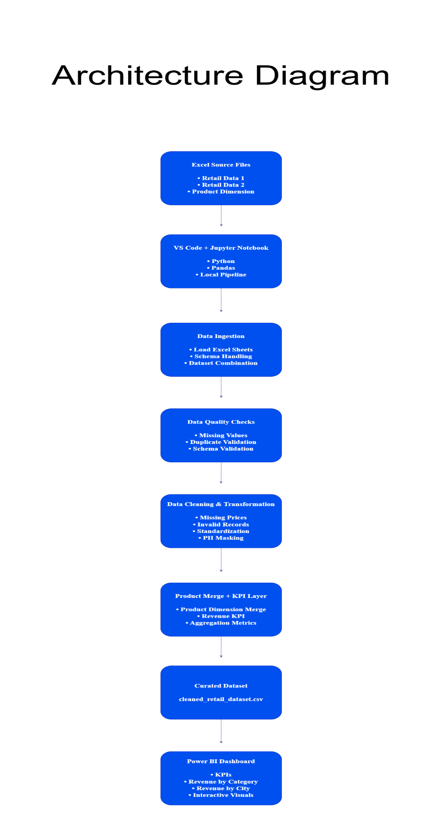

The architecture diagram illustrates the complete end-to-end retail data engineering workflow implemented in this project. The solution follows a layered pipeline architecture beginning with raw source data ingestion and ending with business intelligence reporting through Power BI.
The architecture is composed of multiple processing layers, each responsible for a specific function within the data pipeline.
1. Excel Source Files Layer
The first layer represents the raw input data sources used in the project.
The project uses three Excel-based source datasets:
- Retail Data 1
- Retail Data 2
- Product Dimension Table (product_dim)
The two retail datasets contain transactional business information such as transaction identifiers, customer information, product identifiers, pricing information, quantity values, transaction dates, discounts, payment methods and purchase locations.
The Product Dimension Table serves as the standardized reference dataset containing product metadata including product names, categories and pricing information.
These source files act as the foundation of the complete analytical workflow.

2. VS Code + Jupyter Notebook Processing Environment
The second layer represents the development and processing environment used to build the pipeline.
The complete solution was implemented locally using:
- VS Code
- Jupyter Notebook
- Python
- Pandas
VS Code acts as the primary Integrated Development Environment (IDE) used for development and notebook execution.
Jupyter Notebook provides an interactive environment for step-by-step pipeline implementation, debugging, validation and transformation.
Python serves as the core programming language used to implement the data engineering workflow.
The Pandas library is used extensively for:
- Reading Excel files
- Data manipulation
- Dataset merging
- Validation checks
- Missing value handling
- Aggregation
- Transformation operations
This environment functions as the central processing layer of the architecture.

3. Data Ingestion Layer
The Data Ingestion layer is responsible for importing raw data from the Excel source files into the processing environment.
Data ingestion operations include:
- Loading Excel sheets
- Schema handling
- Dataset combination
Excel datasets are imported using Pandas read_excel() functionality.
During ingestion, multiple worksheets and source files are loaded into Pandas DataFrames.
Since the retail data exists across multiple datasets, ingestion logic combines these datasets into a unified analytical structure.
Schema consistency handling is also performed to ensure columns remain compatible across the imported datasets.
This layer converts raw Excel files into machine-processable structured datasets.

4. Data Quality Checks Layer
The Data Quality Checks layer ensures that imported data satisfies predefined quality requirements before analytical processing begins.
Several validation checks are implemented during this stage.
These include:
- Missing value detection
- Duplicate validation
- Schema validation
Missing value checks are performed to identify incomplete records requiring preprocessing.
Duplicate validation helps identify redundant or repeated transactional records that may negatively affect analytical accuracy.
Schema validation ensures that imported datasets maintain expected column structures, data types and naming consistency.
This layer improves dataset reliability before transformation operations are applied.

5. Data Cleaning & Transformation Layer
This layer represents the primary preprocessing stage of the architecture.
The cleaning and transformation stage is responsible for converting raw transactional records into a standardized analytics-ready dataset.
Several cleaning operations are performed during this stage.
Missing Price Handling
Missing pricing information is handled using product-level average price imputation.
The solution calculates average prices grouped by product_id and fills missing values accordingly.
This prevents analytical distortion caused by incomplete pricing records.
Invalid Record Handling
Business validation rules are applied to identify invalid records.
Examples include:
- Negative price values
- Zero quantity transactions
- Negative quantity values
Invalid records are removed to preserve business logic integrity.
Data Standardization
Several fields required standardization because raw datasets contained inconsistent values.
Examples include:
- ELEC → Electronics
- FURN → Furniture
- HOME APPLIANCES → Home Appliances
Product naming inconsistencies are also standardized using consistent capitalization rules.
Standardization ensures analytical consistency during KPI calculation and reporting.
PII Masking
Since the retail dataset contains customer contact information, privacy protection mechanisms are implemented.
Sensitive customer fields such as:
- Email addresses
- Phone numbers
are masked to reduce exposure of Personally Identifiable Information (PII).
This layer strengthens privacy protection and supports responsible data handling practices.

6. Product Merge + KPI Layer
The Product Merge and KPI layer performs analytical enrichment and metric generation.
The retail transaction dataset is merged with the standardized Product Dimension Table using product_id as the common join key.
This integration enriches transaction records with standardized product information including:
- Product Name
- Category
- Reference Pricing Information
Following dimensional integration, KPI calculations are performed.
A key analytical metric generated within this layer is Revenue.
Revenue is calculated using the formula:
Revenue = Price × Quantity × (1 − Discount)
Additional analytical aggregations are also generated for reporting purposes.
These metrics serve as the foundation for business intelligence visualization.

7. Curated Dataset Layer
The Curated Dataset layer represents the final processed analytical output produced by the pipeline.
After ingestion, validation, cleaning, transformation and metric generation, the completed dataset is exported as:
cleaned_retail_dataset.csv
This curated dataset contains standardized, validated and analytics-ready transactional information.
The exported dataset becomes the official reporting source used by downstream visualization systems.

8. Power BI Dashboard Layer
The final layer represents the reporting and business intelligence component of the architecture.
The curated CSV dataset is loaded into Power BI for dashboard development and visualization.
Several KPIs and analytical views are implemented within the dashboard.
Examples include:
- Total Revenue
- Revenue by Category
- Revenue by City
- Revenue by Payment Method
- Interactive Visual Reports
Power BI enables interactive exploration of business performance through charts, filters, KPI cards and analytical dashboards.
This layer converts processed data into actionable business insights.

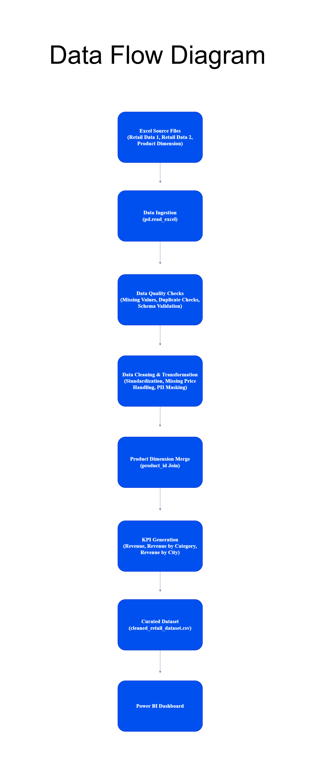
4.Data Flow Diagram

The Data Flow Diagram (DFD) illustrates the movement of data throughout the complete retail data engineering pipeline.
The diagram represents how raw retail transaction data travels through multiple processing stages before being transformed into a finalized analytical dataset suitable for reporting and business intelligence visualization.
The workflow follows a structured sequential flow beginning with source data acquisition and ending with Power BI dashboard reporting.

1. Excel Source Files
The first stage of the data flow process consists of the raw source datasets.
The project uses three Excel-based source files:
- Retail Data 1
- Retail Data 2
- Product Dimension Table (product_dim)
The retail datasets contain transactional business information such as:
- Transaction identifiers
- Customer information
- Product details
- Pricing data
- Quantity information
- Discounts
- Payment details
- Geographic information
The Product Dimension Table contains standardized product reference information used for dimensional enrichment and product standardization.
These source files act as the initial input layer of the data pipeline.

2. Data Ingestion
After acquiring the source files, the next stage involves data ingestion.
The Excel files are imported into the Python processing environment using Pandas.
Data ingestion is implemented using:
pd.read_excel()
During ingestion, the source datasets are converted into structured Pandas DataFrames.
Multiple retail datasets are loaded independently and prepared for downstream processing.
The ingestion stage transforms raw spreadsheet data into machine-readable structured datasets.

3. Data Quality Checks
Following ingestion, data quality validation procedures are applied.
Raw business datasets frequently contain inconsistencies, incomplete records and structural issues.
To ensure analytical reliability, several quality checks are performed.
These checks include:
- Missing value detection
- Duplicate record validation
- Schema validation
Missing value checks identify incomplete fields requiring preprocessing.
Duplicate validation helps detect repeated records that could distort KPI calculations.
Schema validation ensures imported datasets maintain expected column structures and naming conventions.
This stage improves dataset integrity before transformation begins.

4. Data Cleaning & Transformation
Once validation is completed, cleaning and transformation operations are applied.
This stage converts raw transactional records into a standardized analytics-ready dataset.
Several preprocessing operations are performed.
Missing Price Handling
Missing prices are handled using product-based mean imputation.
The pipeline calculates average prices grouped by product_id.
Missing values are then replaced using corresponding product averages.
This preserves pricing consistency across the dataset.
Invalid Record Removal
Business rules are applied to detect invalid transactional entries.
Examples include:
- Negative prices
- Zero quantities
- Negative quantity values
These records violate business logic and are removed from the dataset.
Data Standardization
The raw data contains inconsistent category naming conventions.
Examples include:
- ELEC
- Electronics
- FURN
- HOME APPLIANCES
Standardization logic converts these values into consistent naming formats.
Product names are also standardized using capitalization formatting methods.
PII Masking
Sensitive customer fields including:
- Email addresses
- Phone numbers
are protected through masking techniques.
This strengthens privacy protection and supports responsible handling of Personally Identifiable Information (PII).

5. Product Dimension Merge
After cleaning and standardization, dimensional integration is performed.
The retail transaction dataset is merged with the standardized Product Dimension Table.
The merge operation uses:
product_id
as the common business key.
This integration enriches transactional records with standardized product information including:
- Product Name
- Category Information
- Reference Pricing Data
Dimension integration improves reporting consistency and analytical accuracy.

6. KPI Generation
After dimensional enrichment, KPI generation is performed.
Several business metrics are calculated from the transformed dataset.
A primary KPI implemented in the project is Revenue.
Revenue calculation uses the formula:
Revenue = Price × Quantity × (1 − Discount)
Additional KPIs generated include:
- Total Revenue
- Revenue by Category
- Revenue by City
- Revenue by Payment Method
- Average Revenue
- Total Orders
These metrics form the analytical foundation of the reporting layer.

7. Curated Dataset Creation
Following preprocessing and KPI generation, the final analytical dataset is created.
The transformed data is exported as:
cleaned_retail_dataset.csv
The curated dataset contains:
- Cleaned transactional records
- Standardized categories
- Validated business data
- Integrated product information
- KPI-ready analytical fields
The curated dataset serves as the official reporting source for downstream visualization.

8. Power BI Dashboard
The final stage of the data flow process involves visualization and reporting.
The curated dataset is imported into Power BI.
Power BI uses the processed analytical data to build:
- KPI dashboards
- Revenue visualizations
- Category analysis
- City-level reporting
- Payment method analytics
- Interactive business reports

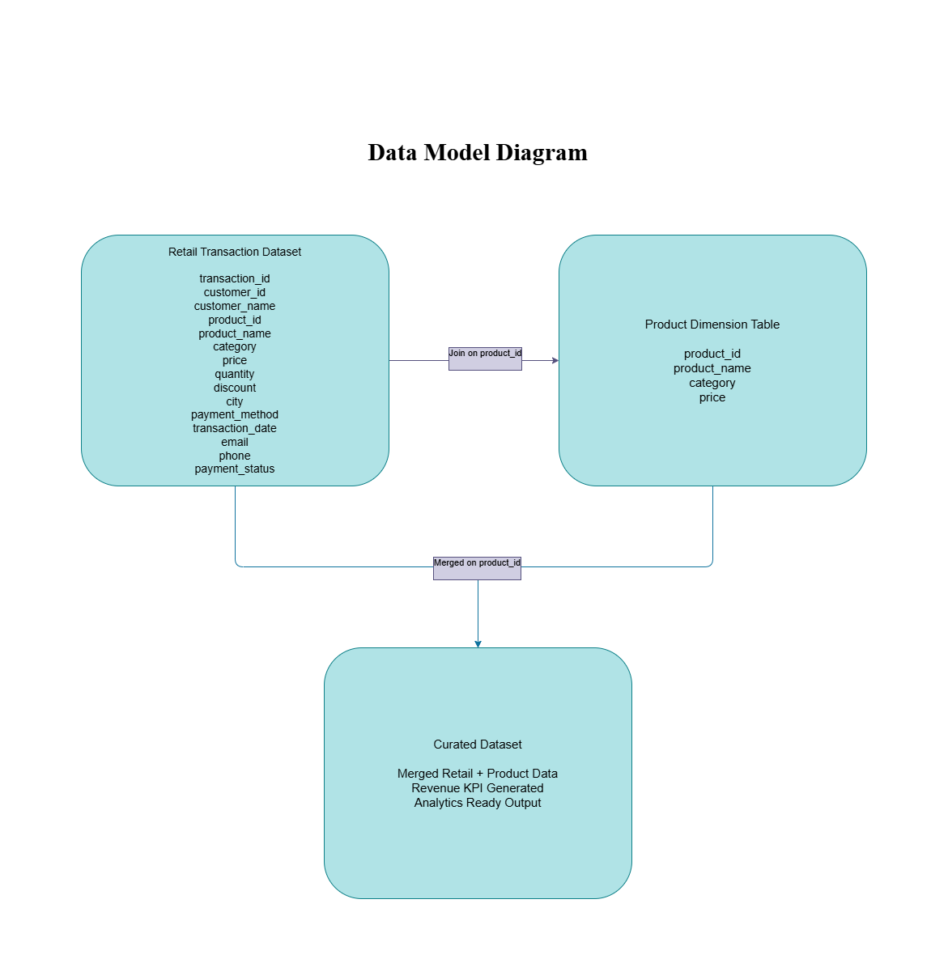
5.Data Model Diagram

The Data Model Diagram illustrates the structural relationship between the datasets used within the retail analytics pipeline.
The project follows a simplified dimensional modeling approach consisting of a Retail Transaction Dataset, a Product Dimension Table, and a final Curated Dataset generated after integration.
The model demonstrates how transactional business data is enriched using standardized product reference information to produce an analytics-ready dataset.

1. Retail Transaction Dataset
The Retail Transaction Dataset acts as the primary fact dataset within the solution.
This dataset contains detailed transaction-level business information generated from retail sales activities.
The dataset includes multiple business attributes such as:
- transaction_id
- customer_id
- customer_name
- product_id
- product_name
- category
- price
- quantity
- discount
- city
- payment_method
- transaction_date
- email
- phone
- payment_status
The retail dataset stores operational sales information required for business analytics, KPI generation and reporting.
Several analytical measures originate from this dataset including:
- Sales transactions
- Quantity sold
- Pricing information
- Discount calculations
- Customer purchases
- Geographic analysis
Because the dataset contains raw transactional records, preprocessing and cleaning operations are performed before analytical usage.

2. Product Dimension Table
The Product Dimension Table acts as the reference dimension dataset within the model.
The purpose of this table is to provide standardized product information that can be used to enrich transactional records.
The Product Dimension Table contains the following fields:
- product_id
- product_name
- category
- price
This table provides standardized metadata related to products and categories.
The dimension table improves analytical consistency by ensuring standardized:
- Product naming
- Category classifications
- Product reference information
- Reporting groupings
Using a dedicated dimension table reduces inconsistencies that may exist within raw transactional datasets.

3. Dataset Relationship (Join Logic)
The relationship between the Retail Transaction Dataset and the Product Dimension Table is established using:
product_id
as the common business key.
The product_id column uniquely identifies products across both datasets.
A merge operation is performed using product_id to integrate standardized product information into the retail transaction records.
The join logic can be represented as:
Retail Transaction Dataset + Product Dimension Table → Curated Dataset
This merge operation enriches transactional records with reliable product metadata required for analytical reporting.

4. Curated Dataset
After integration, the final output generated is the Curated Dataset.
The Curated Dataset represents the completed analytical dataset used for reporting and visualization.
This dataset contains:
- Cleaned retail transactions
- Standardized product information
- Category normalization
- Revenue KPI calculations
- Analytics-ready fields
The Curated Dataset combines transactional business data with product reference information to create a unified reporting source.
This final dataset becomes the official analytical output of the pipeline.
The curated dataset is exported as:
cleaned_retail_dataset.csv

5. Revenue KPI Integration
Following the merge process, KPI generation is performed.
One of the primary analytical metrics generated is Revenue.
Revenue is calculated using the formula:
Revenue = Price × Quantity × (1 − Discount)
Additional business KPIs derived from the curated dataset include:
- Total Revenue
- Revenue by Category
- Revenue by City
- Revenue by Payment Method
- Average Revenue
- Total Orders
These KPIs are later consumed by the Power BI dashboard layer for business intelligence reporting.

6. Assumptions Made
Several assumptions were established during implementation to ensure consistent processing, analytical accuracy and successful pipeline execution.
Product Identifier Assumption
The project assumes that product_id acts as the common business key shared between the Retail Transaction Dataset and the Product Dimension Table.
This identifier is used for merge operations and dimensional enrichment.

Missing Price Handling Assumption
The dataset contained missing pricing values.
It is assumed that products sharing the same product_id should have comparable pricing information.
Therefore, missing prices are filled using the average price grouped by product_id.

Invalid Record Assumption
The project assumes that certain business rules must be enforced to maintain analytical validity.
The following records are treated as invalid:
- Negative prices
- Negative quantities
- Zero quantity transactions
These records are removed because they violate expected retail business logic.

Standardization Assumption
The raw dataset contains inconsistent naming conventions for categories and products.
It is assumed that different textual variations represent the same business entity.
Examples:
- ELEC = Electronics
- FURN = Furniture
- HOME APPLIANCES = Home Appliances
Standardization is applied accordingly.

Privacy Protection Assumption
Customer email addresses and phone numbers are considered Personally Identifiable Information (PII).
The project assumes that sensitive customer information should not remain directly exposed within analytical datasets.
Therefore, masking logic is applied.

Local Implementation Assumption
Although Azure implementation was recommended, the project assumes that a local implementation environment is acceptable.
The complete solution is therefore developed using:
- VS Code
- Jupyter Notebook
- Python
- Pandas
- Power BI

7. Data Cleaning Strategy
The project applies a structured data cleaning strategy to improve data quality, reliability and reporting readiness.
Multiple preprocessing operations are implemented during the pipeline.

Missing Value Handling
Missing values can negatively affect analytical calculations and KPI accuracy.
The dataset is inspected to identify incomplete records.
Special attention is given to:
- Price fields
- Category information
- Product metadata
Missing prices are handled using group-based mean imputation.
Average prices are calculated using product_id grouping logic and used to replace missing values.
This strategy reduces data loss while maintaining pricing consistency.

Duplicate Validation
Duplicate transactions can artificially inflate revenue calculations and transaction counts.
Validation checks are performed to identify duplicate records.
Duplicate validation helps maintain:
- Revenue accuracy
- Order count integrity
- Analytical reliability

Invalid Record Removal
Business validation rules are implemented to detect invalid transactional entries.
The following records are treated as invalid:
- Negative prices
- Zero quantities
- Negative quantities
Invalid records are removed from the analytical dataset.
This preserves business logic integrity.

Category Standardization
The raw datasets contain inconsistent category naming conventions.
Examples include:
- ELEC
- Electronics
- FURN
- HOME APPLIANCES
- home appliances
Standardization logic converts these values into consistent category names.
This ensures correct aggregation and reporting.

Product Name Standardization
Product naming inconsistencies are corrected using normalization rules.
Examples include inconsistent capitalization formats.
Standardization ensures uniform naming conventions across analytical outputs.

Schema Validation
Schema validation is performed during ingestion and preprocessing.
Validation includes:
- Column verification
- Column consistency checks
- Dataset compatibility validation
This ensures smooth integration between datasets.

PII Masking
Sensitive customer fields are protected using masking logic.
Protected fields include:
- Email addresses
- Phone numbers
This reduces direct exposure of confidential customer information.

8. Transformation Logic
The transformation layer converts raw source data into a structured analytics-ready dataset.
The following transformation workflow is implemented.

Step 1 — Load Source Files
The pipeline begins by importing:
- Retail Data 1
- Retail Data 2
- Product Dimension Table
Excel ingestion is performed using:
pd.read_excel()

Step 2 — Dataset Combination
The retail source datasets are combined into a unified transactional dataset.
Dataset concatenation ensures analytical continuity across multiple source files.

Step 3 — Data Quality Validation
Validation checks are performed before preprocessing.
Checks include:
- Missing value detection
- Duplicate validation
- Schema verification

Step 4 — Missing Price Transformation
Missing prices are replaced using product-level average pricing.
Transformation logic:
Group by product_id → Calculate Mean Price → Fill Missing Values

Step 5 — Invalid Record Filtering
Business rules are applied to remove invalid records.
Filtering logic removes:
- Negative prices
- Negative quantities
- Zero quantities

Step 6 — Standardization Logic
Categorical inconsistencies are standardized.
Transformation includes:
- Category normalization
- Product name normalization
- Consistent capitalization formatting

Step 7 — PII Masking
Sensitive customer fields are transformed using masking techniques.
Protected attributes:
- Email
- Phone Number
This improves privacy protection.

Step 8 — Product Dimension Merge
The cleaned retail dataset is merged with the Product Dimension Table.
Merge key:
product_id
This operation enriches transactional data with standardized product information.

Step 9 — KPI Generation
Business metrics are generated from the transformed dataset.
Revenue formula:
Revenue = Price × Quantity × (1 − Discount)
Generated KPIs include:
- Total Revenue
- Revenue by Category
- Revenue by City
- Revenue by Payment Method
- Average Revenue
- Total Orders

Step 10 — Curated Dataset Export
The final processed dataset is exported as:
cleaned_retail_dataset.csv
This dataset becomes the official reporting source for Power BI.

9. Visual Insights
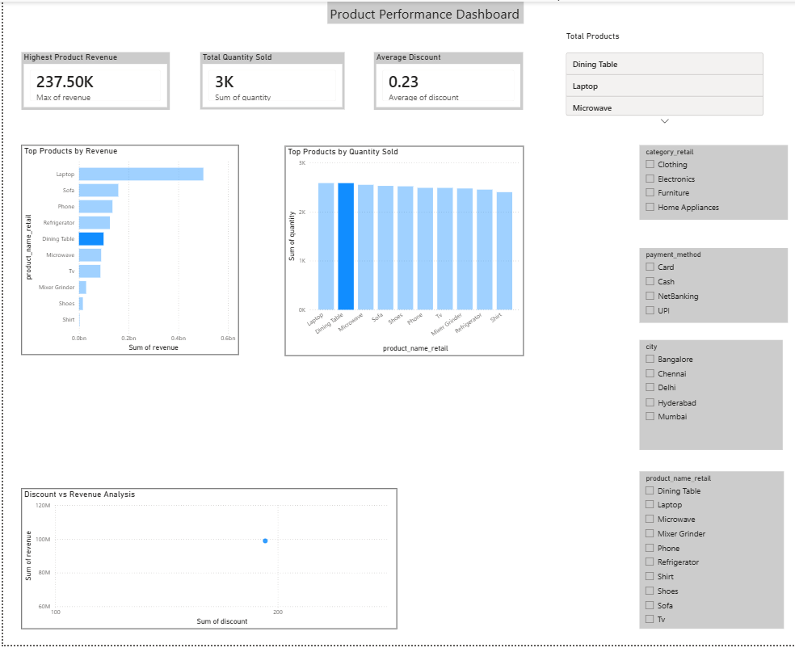
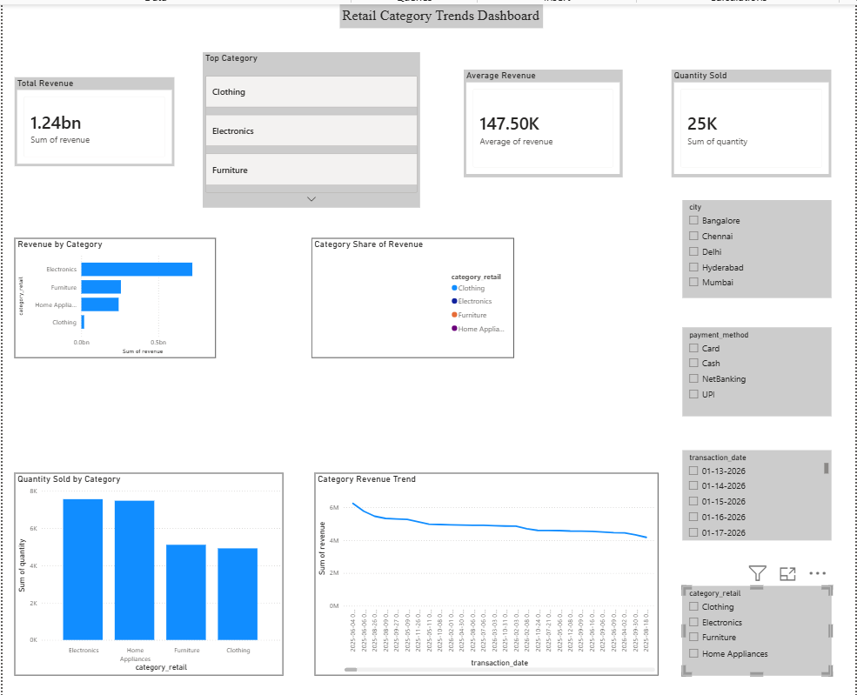
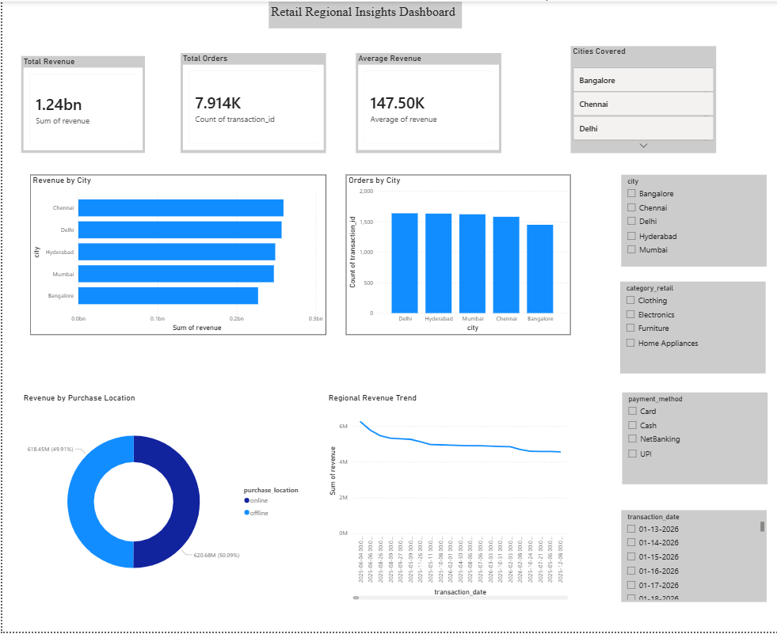
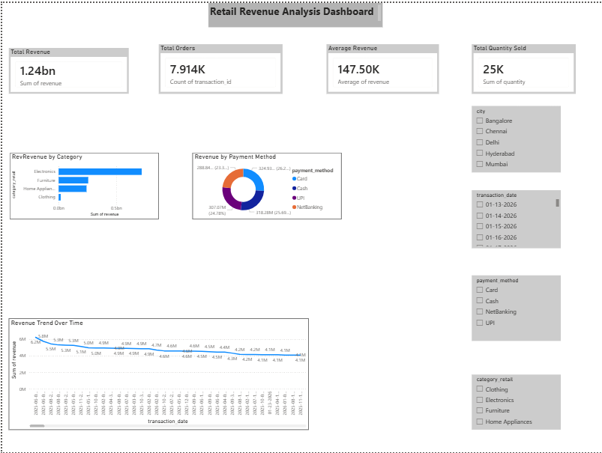
The Power BI dashboards developed in this project provide analytical insights into retail sales performance, product behavior, category trends and regional business performance.
Interactive visuals, KPI cards, filters and slicers were used to support exploratory business analysis and decision making.
The dashboard was organized into four analytical sections:
- Revenue Analysis
- Product Performance
- Category Trends
- Regional Insights

Revenue Analysis Insights
The Revenue Analysis dashboard focuses on overall business performance and sales metrics.
The dashboard contains KPI cards showing:
- Total Revenue
- Total Orders
- Average Revenue
- Total Quantity Sold
Revenue analysis identified overall business sales performance across the retail environment.
The Revenue by Category visualization highlights category-wise contribution toward total revenue.
Certain categories demonstrate stronger business performance compared to others, indicating potential high-value product segments.
The Revenue by Payment Method chart provides insight into customer payment preferences.
This visualization helps identify dominant payment channels and customer transaction behavior.
The Revenue Trend Over Time visualization supports time-series analysis by illustrating revenue movement across transaction dates.
This enables monitoring of sales growth patterns, performance fluctuations and operational trends.
Interactive slicers allow users to dynamically filter the dashboard by:
- City
- Category
- Payment Method
- Transaction Date
These filters improve analytical flexibility and user interaction.

Product Performance Insights
The Product Performance dashboard focuses on individual product behavior and product-level business contribution.
The dashboard includes KPIs such as:
- Highest Product Revenue
- Total Quantity Sold
- Average Discount
- Total Products
The Top Products by Revenue visualization identifies products generating the highest financial contribution.
This insight helps businesses recognize top-performing products and prioritize inventory or marketing strategies.
The Top Products by Quantity Sold chart highlights products with the highest sales volume.
High-quantity products may indicate strong customer demand and operational importance.
The Discount vs Revenue Analysis scatter plot helps evaluate the relationship between discounts and revenue generation.
This analysis provides insights into pricing effectiveness and promotional strategy outcomes.
Product-level slicers and filters enable targeted analysis across:
- Products
- Categories
- Cities
- Payment Methods
These interactive controls enhance analytical depth and usability.

Category Trends Insights
The Category Trends dashboard analyzes business performance from a category perspective.
The dashboard includes measures related to:
- Revenue Performance
- Quantity Sold
- Category Contribution
- Revenue Trends
The Revenue by Category chart compares financial performance across product categories.
This helps identify dominant business categories contributing significantly to revenue generation.
The Category Share of Revenue donut chart visualizes category contribution percentages.
This enables proportional analysis of revenue distribution.
The Quantity Sold by Category visualization measures category-level product movement.
This helps identify categories with strong customer demand.
The Category Revenue Trend chart enables time-based analysis of category performance.
Businesses can use this insight to monitor category growth patterns and seasonal fluctuations.
Interactive filters allow deeper exploration by:
- Category
- City
- Payment Method
- Transaction Date
This improves analytical flexibility and supports customized reporting.

Regional Insights
The Regional Insights dashboard focuses on geographic sales performance and location-based business analysis.
The dashboard contains KPI cards including:
- Total Revenue
- Total Orders
- Average Revenue
- Cities Covered
The Revenue by City visualization highlights city-level financial contribution.
This analysis helps identify high-performing operational regions and important market locations.
The Orders by City chart measures transaction activity across geographic locations.
This insight supports evaluation of customer activity concentration across regions.
The Revenue by Purchase Location chart analyzes revenue generated through different purchase channels.
This helps understand customer purchasing behavior across operational environments.
The Regional Revenue Trend visualization supports time-series monitoring of geographic business performance.
Users can identify changes in city-level performance over time.
Regional filters allow focused analysis using:
- City
- Category
- Payment Method
- Transaction Date
These interactive controls support detailed regional performance investigation.

